**Current hypotheses:**

**Hypothesis 1:** Predation by native species (ruru or falcon) is reducing adult survival.

*Some cameras have been put up on active nest boxes the past two seasons, but no predation events have been observed at the nest boxes. See Table 4 for observed predation mortality records.*

**Hypothesis 2:** Birds are moving outside of the fence into surrounding neighborhoods to feed and are being depredated, reducing adult and fledgling survival.

**Hypothesis 3:** Birds are dispersing away from Zealandia and thus are lost to the population, functioning from the standpoint of the population as a reduction in survival.

* *Some evidence to support dispersal into surrounding neighborhoods. There are reports and sightings of Hihi every year, usually between 10-30 sightings, and across all months of the year. Both females and males are seen outside the fence, more frequently male but this may just reflect the relative abundances of males compared to females. The greenspaces directly surrounding Zealandia are where most sightings are reported (Wright’s Hill, Karori, Highbury, Waimapihi).*
* *A dispersal study on korimako/bellbirds and Hihi was carried out in 2009. Transmitters were attached to nine female Hihi after the breeding season. The females were tracked for 29-126 days with some dropping their transmitters and only 3 being recaptured for removal, so results are based on these 3 females. Despite the female Hihi being only rarely seen at the feeders during this period, there was little evidence that they were foraging outside. The only female recorded to be outside the fence was found predated 100 m from the fence (Campbell Street gate).*
* *Female Korimako were found to travel long distances outside the reserve (see Figure 1 below).*
* *Map of Zealandia and surrounding green spaces is provided for context below (see Figure 2 below).*
* *Kākāriki dispersal: male-biased dispersal, 11/22 birds permanently dispersed out of Zealandia, and 27-45% of the birds that dispersed outside the sanctuary were killed within the study period of just a few months. The distance dispersal decreased with increasing body condition. FROM Irwin, E. (2017). Breeding biology and post-fledging dispersal of red-crowned parakeets (Cyanoramphus novaezelandiae) translocated to a fenced mainland sanctuary. (See Figure 3 below).*

*Figure 1. Results of study on Korimako movement outside Zealandia.*

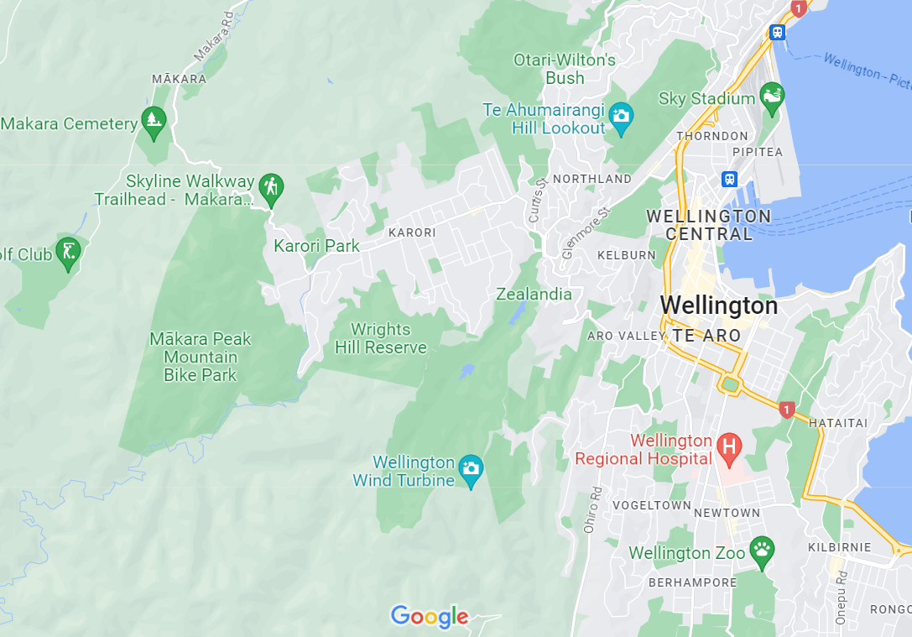



*Figure 2. Landscape context of Zealandia.*

*Figure 3. Figure on movement of Kakariki outside of Zealandia, reproduced from original paper.*

**Hypothesis 4:** Inbreeding depression is reducing survival and/or breeding success and thereby dampening population growth.

* *Genetic evidence of inbreeding in Zealandia Hihi prior to 2014 but would need to be redone. Zealandia was more inbred than other sites but more work to be done in this space. Working with Anna on this. Evidence from Tiritiri population that inbred individuals had reduced number of offspring (likely the same at Zealandia). (Figure 4 below)*

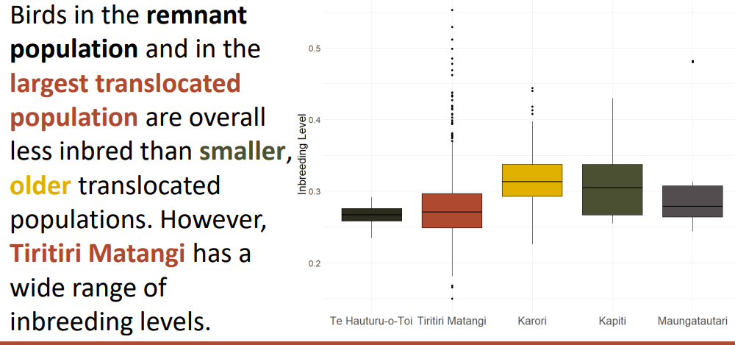

*Figure 4. Graph borrowed from Laura Duntsch’s poster on Hihi Inbreeding.*

**Hypothesis 5**: A male-skewed sex ratio is resulting in harassment of females by males, which reduces female survival or breeding success.

* *There are observations of male harassment of females at feeders and nest boxes. Anecdotally, this appears worse in recent years with greater sex ratio imbalance but not confirmed through analysis.*
* *Females regularly succumb to stress from intense male harassment [evidence from data base of death}*
* *Figure 5 below provides a plot of the known population, by sex, since 2005. Table 1 in the ‘GENERAL INFORMATION’ section, below, provides this information in tabular form.*

**Figure 5**: The known population of hihi at the start of each breeding season at Zealandia Te Māra a Tāne between 2005-2022. The solid lines show the adult population, and the dotted lines represent the population of juveniles that survived over winter to enter the population as first-year adults. The known population is determined by feeder surveys and casual observations of banded individuals.

**Hypothesis 6:** Weather events, specifically cold temperatures in the early breeding season, reduce breeding success and survival of females.

* *Temperature data collected in nest boxes from 2020-2023 provided some evidence (not statistically sound due to small sample sizes) of nest failures, particularly at the egg stage, coinciding with low temperatures. Early in the season when spring temperatures fluctuate, nest failures appear to occur together around the time of weather events coming through. Figure 7 provides information on nest failure by egg stage. Figure 8 provides information on the timing and fate of early nests.*

**Figure 6**: The number of nests with eggs that failed to hatch each year at Zealandia Te Māra a Tāne between 2005-2022.The nest failures are organized by clutch.

**Figure 7**: The timing and outcome of early nests in the 2021-22 season between October and January. Yellow bars indicate nests that resulted in nestling mortality, red indicates nests that resulted in hatching failure, and green indicates successful nests that resulted in at least one fledgling.

**Hypothesis 7:** Disease, either aspergillosis or others (e.g., Toxoplasmosis, trematodes, Plasmodium sp., avian malaria, internal or external parasites), is reducing adult survival, fledgling survival, or breeding success.

* **Paper on *candida* *albicans* infection in hihi at Zealandia:** Rippon, R. J., Alley, M. R., & Castro, I. (2010). Candida albicans infection in free-living populations of hihi (stitchbird; Notiomystis cincta). *New Zealand Veterinary Journal*, *58*(6), 299-306.

See Table 4 in the ‘GENERAL INFORMATION’ section for a summary of observed deaths from disease.

**Hypothesis 8:** Current habitat conditions result in poor nutrition (quality or quantity of food) and reduced survival.

* *No direct evidence of this on hand. We have sugar water consumption data available from each year (Figure 8) and we do see quite a drop in consumption over winter indicating they are using other food sources.*
* *Vegetation plot data following changes in the forest have been collected regularly since before the fence went up and is available for analysis but not yet summarized.*

**Figure 8:** Monthlysugar water consumption between 2014 and 2023 at Zealandia Te Māra a Tāne. Total sugar water consumption was calculated for every month and is represented in ml per day. The average total consumption per month is illustrated with the dotted line.

Some interacting combination of factors:

* **Hypothesis 9a:** Weather events (Hypothesis 6) are causing females to approach feeders at a higher rate, where they are harassed by males (Hypothesis 5), which is reducing female survival and breeding success.
* **Hypothesis 9b:** Inbreeding depression (Hypothesis 4) is increasing the disease susceptibility of Hihi (Hypothesis 7), thereby reducing survival and breeding success.
* **Hypothesis 9c:** Weather events (Hypothesis 6) are causing stress to females, making them susceptible to disease (Hypothesis 7), reducing female survival.
* **Hypothesis 9d:** A male-skewed sex ratio (Hypothesis 5) is increasing the rate of female dispersal out of Zealandia (Hypotheses 2 and 3), thereby reducing female survival.
* **Hypothesis 9e:** The current habitat conditions (Hypothesis 8) are such that birds are dispersing out of Zealandia to find food (Hypotheses 2), reducing adult and fledgling survival.
* **Hypothesis 9f:** Current habitat conditions and poor nutrition (Hypothesis 8) are increasing Hihi’s susceptibility to disease (Hypothesis 7), reducing survival.

**Hypothesis 10:** Hihi get killed from hitting fences, reducing survival.

* *No evidence. The fence is checked daily and any observed instances would be reported.*

**Hypothesis 11:** Hihi chicks are being fed wasps, causing internal trauma from stingers and leading to death, reducing overall chick and fledgling survival.

* *Some evidence that this does happen. The necropsies of 9 juvenile hihi have indicated traumatic ventriculitis from ingesting stingers. Chick necropsies have not always been regularly done but during periods where there is a focus on sending for necropsy we seem to come across some cases. There are likely more cases of this in our population, but it would need to be looked at more closely to understand the population effect.*
* **Paper on hihi chicks ingesting wasp stingers at Zealandia:** Rippon, R. J., Alley, M. R., & Castro, I. (2013). Traumatic ventriculitis following consumption of introduced insect prey (Hymenoptera) in nestling hihi (Notiomystis cincta). *Journal of Wildlife Diseases*, *49*(1), 80-90.
* See Table 4 in the ‘GENERAL INFORMATION’ section below for a summary of observations.

**Hypothesis 12:** Hihi are consuming poisoned baits, either through primary or secondary poisoning, causing reduced adult survival.

* *No evidence of this from necropsies. Only found in some kākā over the years. No evidence in species like toutouwai that would likely be susceptible to secondary poisoning. This type of mortality could go unobserved.*

**Hypothesis 13:** Hihi are being caught in mammalian traps and other control tools, reducing adult survival.

* *One hihi was caught in a trap in an external trapping network. Traps at Zealandia are usually only set for incursions.*

**Hypothesis 14:** Wasps are limiting nectar and insects, reducing adult survival.

* *Moderate to high numbers of wasps at the feeders most years, feeding alongside hihi. Wasps are consuming high levels of the sugar water, but we adjust the amount provided to ensure there is always some available. One report of a female hihi observed to have been stung by a wasp at a feeder when the sugar water had run out and the wasps were agitated.*

**Hypothesis 15:** Competition with mice for insects and seeds is reducing survival.

* *We conduct our annual mouse control operation every year to maintain reasonably low numbers of mice. We have data available from our mouse index lines that are performed in conjunction with the bait operation and have data on bait-take as well. These could be used to estimate a mouse population year to year and see how it ties into trends with hihi.*

**Hypothesis 16:** Inter and intraspecific competition is reducing supplementary feeding resources for female adult Hihi, reducing female survival.

* *Data are available from feeder surveys on the number of bellbirds feeding compared to hihi. There are bellbirds present at all the feeding sites but in low numbers. A portion of the Korimako population was banded in 2021 (~20 individuals) and only a few were seen unbanded following that. Likely a very small population. No other birds access the feeders other than an odd creative tui with acrobatic skills for a brief period. No dominant behavior of tui at the feeders.*
* *Female hihi are often harassed at feeders by males but will sometimes feed alongside social partners or when there is a gap in feeder visitation.*
* *Females are usually only seen at the feeders in November-January (depending on peak laying/rearing that season). Virtually no sightings of females between March-October.*

**Hypothesis 17:** Hihi rearing is phenologically asynchronous with invertebrate prey availability, leading to poor survival.

* *No available data but some anecdotal evidence that may support this. There has been a pattern we have noticed in the past few season of hihi chicks appearing malnourished, failing to thrive, and appearing to have died of starvation (no necropsy confirmation—bad luck with timing). In many cases the nests were seen to be attended still and were not abandoned. Other monitored avian species in the valley that also feed on insects (toutouwai) were showing similar signs at the same time. We thought about low insect availability but since wondered if the parasitic infections were to blame.*

**GENERAL INFORMATION**

**Paper on causes of hihi chick deaths at Zealandia (2011):**

Rippon, R. J., Alley, M. R., & Castro, I. (2011). Causes of mortality in a nestling population of free-living hihi (stitchbird—Notiomystis cincta). *New Zealand Journal of Zoology*, *38*(3), 207-222.

**Table 1**: Known population numbers in September of each year from 2005-2022 at Zealandia Māra a Tāne. The proportion of the population that are first-year birds is shown in brackets. Note: the statistics from 2021/22 have been updated with Individuals that remained unsighted in 2021/22 but have since been confirmed as alive.

|  |  |  |  |
| --- | --- | --- | --- |
| **Year** | **Males** | **Females** | **Total population** |
| **2005** | 16 | 19 | 35 |
| **2006** | 25 (72%) | 17 (47%) | 42 |
| **2007** | 36 (56%) | 14 (50%) | 50 |
| **2008** | 32 (56%) | 19 (79%) | 51 |
| **2009** | 26 (38%) | 14 (64%) | 40 |
| **2010** | 21 (48%) | 22 (55%) | 43 |
| **2011** | 37 (51%) | 25 (72%) | 65 |
| **2012** | 52 (62%) | 23 (61%) | 75 |
| **2013** | 40 (20%) | 28 (57%) | 68 |
| **2014** | 55 (55%) | 36 (47%) | 91 |
| **2015** | 61 (41%) | 40 (48%) | 101 |
| **2016** | 67 (39%) | 31 (35%) | 98 |
| **2017** | 71 (42%) | 41 (37%) | 112 |
| **2018** | 76 (18%) | 22 (18%) | 98 |
| **2019** | 60 (29%) | 25 (52%) | 85 |
| **2020** | 69 (28%) | 37 (32%) | 106 |
| **2021** | 68 (32%) | 22 (23%) | 90 |
| **2022** | 48 (4%) | 12 (25%) | 60 |

**Table 2:** Juvenile survival over winter measured in September each year as the number of known individuals re-sighted. Note: statistics have been updated with Individuals that remained unsighted but have since been confirmed as alive or whose sex has been confirmed to be different than recorded at banding.

|  |  |  |  |  |  |
| --- | --- | --- | --- | --- | --- |
| **Year** | **Juvenile males** | | **Juvenile females** | | **Total** |
| No. | Proportion of cohort | No. | Proportion of cohort |
| **2006** | 18 | 44% | 8 | 26% | 26 |
| **2007** | 20 | 53% | 7 | 33% | 27 |
| **2008** | 18 | 78% | 15 | 47% | 33 |
| **2009** | 11 | 36% | 9 | 27% | 20 |
| **2010** | 10 | 42% | 12 | 50% | 22 |
| **2011** | 19 | 54% | 18 | 50% | 37 |
| **2012** | 32 | 67% | 14 | 34% | 36 |
| **2013** | 8 | 38% | 16 | 43% | 24 |
| **2014** | 30 | 63% | 17 | 59% | 46 |
| **2015** | 26 | 63% | 19 | 59% | 45 |
| **2016** | 26 | 52% | 11 | 85% | 37 |
| **2017** | 30 | 67% | 15 | 63% | 45 |
| **2018** | 15 | 52% | 4 | 50% | 19 |
| **2019** | 15 | 58% | 13 | 59% | 28 |
| **2020** | 19 | 86% | 12 | 71% | 31 |
| **2021** | 22 | 79% | 6 | 38% | 28 |
| **2022** | 2 | 22% | 3 | 15% | 5 |

**Table 3:** Nesting success for breeding seasons at Zealandia Māra a Tāne, 2005-2022. Statistics reported in blue denote the inclusion of natural nests. The presence of natural nests is assumed based on sightings of un-banded fledglings.

|  |  |  |  |  |  |  |  |  |  |  |
| --- | --- | --- | --- | --- | --- | --- | --- | --- | --- | --- |
| **Season** | **Females** | | **No. of clutches** | **Mean clutch size** | **eggs laid** | **Eggs hatched** | **fledglings** | **Eggs fledged**  **(%)** | **fledglings / breeding female** | **Natural nests\*** |
| Total | breeding |
| **2005/6** | 19 | 17 | 4 | 4.1 | 171 | 121 (71%) | 89 | 52 % | 5.2 | 0 |
| **2006/7** | 17 | 15 | 3 | 4.1 | 118 | 85 (72%) | 69 | 58 % | 4.6 | 0 |
| **2007/8** | 14 | 12 | 4 | 4.0 | 110 | 72 (65%) | 51 | 46 % | 4.3 | -- |
| **2008/9** | 19 | 18 | 3 | 4.0 | 149 | 82 (55%) | 50 | 34 % | 2.8 | 0 |
| **2009/10** | 14 | 13 | 3 | 3.9 | 110 | 60 (55%) | 43 | 39 % | 3.3 | 0 |
| **2010/11** | 22 | 19 | 4 | 4.1 | 170 | 97 (57%) | 74 | 44 % | 3.9 | -- |
| **2011/12** | 25 | 20 | 3 | 4.1 | 185 | 107 (58%) | 84 | 46 % | 4.2 | -- |
| **2012/13** | 23 | 16 | 3 | 4.1 | 127 | 66 (52%) | 58 | 46 % | 3.6 | -- |
| **2013/14** | 28 | 26 | 3 | 3.9 | 195 | 108 (55%) | 90 (105) | 46 % | 4.0 | 4 |
| **2014/15** | 36 | 28 (29) | 3 | 4.0 | 218 | 118 (54%) | 74 (79) | 34 % | 2.7 | 1 |
| **2015/16** | 40 | 32 (33) | 4 | 4.0 | 259 | 141 (54%) | 91 (95) | 35 % | 2.9 | 1 |
| **2016/17** | 31 | 27 (29) | 3 | 3.9 | 185 | 97 (52%) | 80 (87) | 43 % | 3.4 | 2 |
| **2017/18** | 41 | 27 (30) | 3 | 3.8 | 188 | 93 (49%) | 50 (56) | 27 % | 1.9 | 3 |
| **2018/19** | 22 | 21 (22) | 3 | 3.9 | 193 | 119 (62%) | 72 (76) | 39 % | 3.5 | 1 |
| **2019/20** | 23 | 17 | 2 | 3.7 | 73 | 45 (62%) | 36 | 49 % | 2.1 | 0 |
| **2020/21** | 37 | 21 (22) | 2 | 3.63 | 127 | 65 (51%) | 59 (61) | 47% | 2.8 | 1 |
| **2021/22** | 22 | 17 (18) | 3 | 3.65 | 135 | 64 (47%) | 33 (35) | 24% | 1.7 | 1 |
| **2022/23** | 12 | 11 | 3 | 3.9 | 85 | 56 (66%) | 34 | 40% | 3.1 | 0 |

**Table 4.** Summary of observed mortalities by cause.

|  |  |  |  |
| --- | --- | --- | --- |
| **Cause** | **Year** | **Sex and age** | **Comments** |
| ***Aspergillosis (n=21)*** | 2005 | Male adult (n=3) | None |
| 2006 | Male adult (n=3),  Female adult (n=2),  Male Subadult (n=1), Male Juvenile (n=1) | Male adult: starvation & chronic pulmonary aspergillosis |
| Female adult: As well as splenic hemosiderosis |
| Female adult: Ventricular nematodiasis |
| Male subadult: pectoral abscess-aspergillosis |
| 2007 | Male adult (n=2) | None |
| 2008 | Female adult (n=2), Female juvenile (n=2) | Female juvenile: Chronic fungal infection, probably Aspergillosis- bird found with splayed legs, neurological symptoms & paralysis |
| Female juvenile: Ophthalmitis, bursitis with abscess. Positive for aspergillosis |
| Female adult: Aspergillosis and pulmonary granulomatous disease. |
| Female adult: Aspergillosis. Also had intestinal nematodes |
| 2011 | Male adult (n=2) | Male adult: Aspergillosis |
| Male adult: Sever aspergillosis |
| 2012 | Male adult (n=1), Male subadult (n=1) | Male adult: Aspergillosis |
| Male subadult: Aspergillosis |
| 2014 | Male adult (n=1) | Male adult: Aspergillosis |
| ***Traumatic ventriculitis (wasp stinger) (n=9)*** | 2008 | Chick (n=1) | Traumatic ventriculitis |
| 2009 | Chick (n=6),  Female adult (n=1) | Chick: Traumatic ventriculitis multifocal granulomatous associated with insect remnants and bacteria. -Myositis and pneumonia - acute multifocal bacterial |
| Chick: Ventriculitis - multifocal granulomatous in muscle and serosa containing insect remnants 2. Myositis, myocarditis, and pneumonia - acute multifocal bacterial |
| Chick: Ventriculitis - localized due to foreign body (Insect remnant?), acute bacteria septicemia, myositis and myocarditis - moderate acute multifocal necrotizing |
| Chick: Ventriculitis - localised due to foreign body (insect remnant?), Myositis - acute multifocal bacterial, terminal bacteremia |
| Chick: Ventriculitis - localised due to foreign body (insect remnant?), Myositis - acute multifocal bacterial, Terminal bacteremia |
| Chick: Ventriculitis, candida |
| Female adult: peritonitis-granulomatous ass insect remains |
| 2023 | Juvenile (n=1) | Juvenile: traumatic ventriculitis with secondary candidiasis |
| ***Predation (n=14)*** | 2005 | Female subadult (n=1),  Female adult (n=1) | Female subadult: Brooklyn |
| 2006 | Male juvenile (n=1) | Male juvenile: Kārearea predation |
| 2009 | Female juvenile (n=1) | Female juvenile: Predated, Campbell street found under netting. |
| 2011 | Female adult (n=2), Male adult (n=1) | Female adult: Predation or window strike, found in Highbury. |
| Female adult: Killed by a cat , Versailles street |
| Male adult: Ruru predation? Remains found in front of nest box near where ruru nested |
| 2012 | Female adult (n=1) | Female adult: killed & eaten by servals |
| 2014 | Male adult (n=1) | Male adult: Avian predation inside the sanctuary |
| 2016 | Female adult (n=1) | Female adult: Predation, decomposed, Karori |
| 2017 | Male adult (n=2) | Male adult: Polhill, leg found in tieke nest. |
| Male adult: Mustelid predation, Karori |
| 2018 | Male subadult (n=1) | Male subadult: Highbury, found under someone’s couch |
| 2019 | Adult (n=1) | Adult: Leg’s found in garden (Campbell street) |
| ***Trauma (n=14)*** | 2006 | Male adult (n=1), Female subadult (n=1) | Female subadult: Caught in a feeder and was badly pecked |
| 2007 | Male adult (n=2),  Male juvenile (n=1), Female juvenile (n=1) | Male adult: Found within feeding cage. |
| Female juvenile: Starvation and head trauma |
| Male juvenile: trauma to thorax & starvation |
| Male adult: trauma - seen being attacked by bellbird 2hr before death |
| 2008 | Female adult (n=2),  Chick (n=1) | Female adult: dent in cranium so probably died due to impact. Found along track. |
| Chick: head trauma. Oral and cloacal swabs analysed by Rosemary Rippon |
| Female adult: Head trauma |
| 2012 | Male adult (n=1) | Male adult: injury leading to osteomyelitis of proximal humerus? |
| 2014 | Juvenile (n=1) | Juvenile: Unknown trauma, found disoriented falling down the discovery steps |
| 2016 | Male adult (n=1) | Male adult: Trauma injuries, polhill |
| 2020 | Male adult (n=1) | Male adult: Muscle trauma to in right pectoralis muscle resulting in starvation from inability to fly. |
| 2021 | Female juvenile (n=1) | Female juvenile: Compressive injury with fractures to pelvis and synsacrum. Herniation of intestines through cloaca. |
| ***Coccidia (n=2)*** | 2005 | Male adult (n=1) | None |
| 2011 | Male juvenile (n=1) | coccidiosis? |
| ***Viral inflammation of the heart and liver (n=4)*** | 2006 | Chick (n=4) | None |
| ***Starvation (n=3)*** | 2006 | Male adult (n=1) | Male adult: Had aspergillosis as well. |
| 2007 | Female juvenile (n=1) | Female juvenile: Starvation and head trauma |
| 2009 | Female adult (n=1) | Female adult: tangled in Uncinia |
| ***Plasmodium (n=2)*** | 2009 | NA (n=1) | Unknown: Renal failure due to nephrosis associated with Plasmodium-like organism |
| 2023 | Juvenile (n=1) | Juvenile: X3 chicks that showed lung and other internal issues that were reminiscent of avian malaria but not confirmed. |
| ***Candidiasis (n=6)*** | 2008 | Chick (n=3) | Chick: Candida albicans |
| Chick: Candida albicans |
| Chick: Candida albicans; Traumatic ventriculitis |
| 2009 | Chick (n=2) | Chick: Traumatic ventriculitis |
| Chick: Traumatic ventriculitis |
| 2023 | Juvenile (n=1) | Juvenile: Traumatic ventriculitis |
| ***Endoparasites (n=5)*** | 2005 | Female juvenile (n=1) | Female juvenile: Hemorrhagic shock following jugular venipuncture; liver & intestinal changes a result of earlier parasite infections? |
| 2006 | Male adult (n=1), Female adult (n=1) | Male adult: ventricular nematodiasis & duodenal trematodiasis (both probably non-pathogenic) |
| Female adult: Ventricular nematodiasis |
| 2008 | Female adult (n=1) | Female adult: Intestinal nematodes |
| 2022 | Female juvenile (n=1) | Female juvenile: Enteric trematodiasis and reduced body condition. Reduced body condition, which will be in large part due to a heavy burden of mostly adult flukes |
| ***Other (n=20)*** | 2006 | Female subadult (n=1), male subadult (n=1), chicks (n=3) | Chick: Hepatic necrosis gram neg bacillus |
| Chick: renal tubular degeneration, dehydration |
| Female subadult: oral fistula, unk cod |
| Male subadult: esophageal fistula - foreign body? |
| 2007 | Chick (n=2) | Chick: external yolk sac? |
| Chick: aspirated ingesta |
| 2008 | Female adult (n=2) | Female adult: acute peritonitis |
| Female adult: Caseous pericarditis |
| 2009 | Chick (n=1),  Juvenile (n=1) | Chick: Respiratory failure |
| Juvenile: Mycotic bronchiectasis and pneumonia, fungal hyphae, see path report |
| 2010 | Female adult (n=1) | Female adult: Died in Wgtn Zoo 29/11/10 having been caught due to eye injury and loss of mobility. |
| 2011 | Male adult (n=2) | Male adult: unknown-glycogen accumulation in liver |
| Male adult: euthanaised at Wgtn Zoo - foot infection |
| 2013 | Female adult (n=1) | Female adult: Caught in a trap in Polhill waimapihihi reserve |
| 2015 | Male juvenile (n=1), Female adult (n=1) | Male juvenile: Found sick on ground, subsequently died had possibly ingested mushrooms. Fungal (mycotic) pneumonia & possibly encephalitis |
| Female adult: Found sick in feeder had been noted weak and timid, subsequently died. Mycotic (fungal) pneumonia |
| 2016 | Male adult (n=1) | Male adult: Renal Gout, Right leg bacteria osteomyelitis |
| 2023 | Juvenile (n=3) | Juvenile: Lung congestion and collapse of atrial and air capillary. |
| Juvenile: Lung congestion and collapse of atrial and air capillary. |
| Juvenile: Lung congestion and collapse of atrial and air capillary. |

**Figure 9** Percentage of juvenile male and female hihi surviving to the following breeding season at Zealandia Te Māra a Tāne between September 2006-2022.

**Figure 10:** Key nest success metrics for the hihi population at Zealandia Te Māra a Tāne across breeding seasons (2005-2022/23). The number of breeding females (A) known to have nest attempts in nest boxes. The number of eggs, chicks, and fledglings produced per breeding female (B).